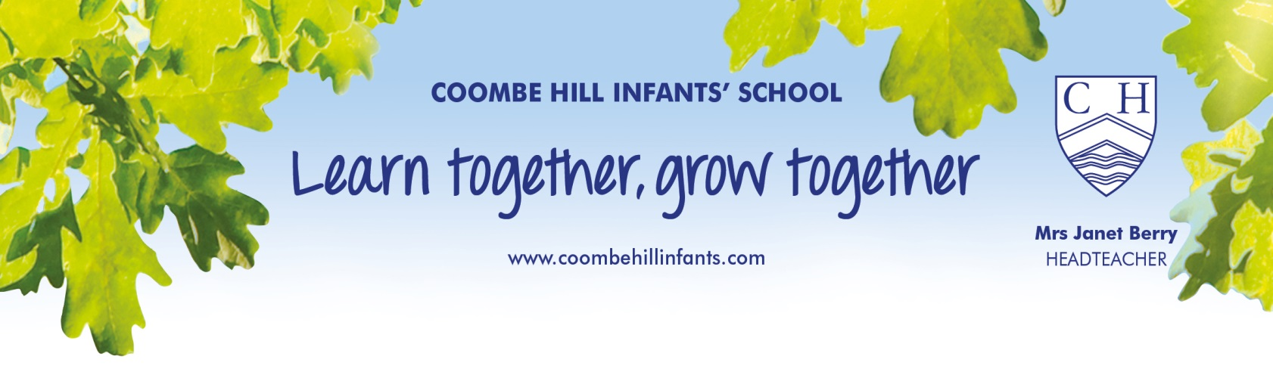
Expectations of Learning
in
Key Stage 1

Updated November 2019

Key Stage 1 (KS1) = Years 1 and 2 (age 5-7)

Core Subjects = English, Maths & Science

Foundation Subjects = Art, Computing, Design & Technology, Geography, History, Music and Physical Education

New National Curriculum = introduced in September 2014 – a more demanding curriculum with higher expectations - greater focus on grammar and spelling and in-depth understanding of concepts and ideas.

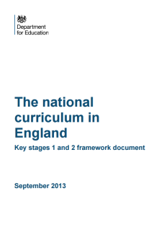
(see The national curriculum - GOV.UK
https://www.gov.uk/national-curriculum/overview)

Also, please see our website for information on termly plans, topics and information on how we cover the National Curriculum

Coombe Hill Infants School - Home
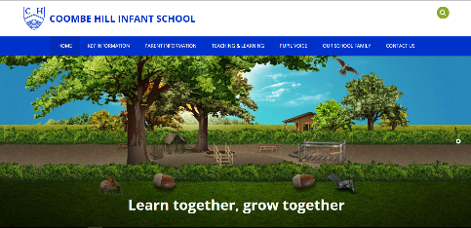
www.coombehillinfants.com/

Finding out more about the curriculum at Coombe Hill Infant School

We follow the National Curriculum and our dedicated and creative staff find the most exciting and interesting ways to cover the statutory requirements. Our curriculum is further enriched by teaching through inspiring areas of interest and high quality texts. We go out on educational visits to farms, castles, parks, theatres, museums, towns plus we enjoy visits from theatre groups, drama workshops, planetariums, scientists, doctors etc at school ….!
We invite you to Year Group Curriculum events during the year and we would strongly encourage you to attend as we aim to give you information to help you support your child’s learning. Our aim is to inform you how we teach at school so you feel more confident about helping your child.
We have an open door policy which allows you to discuss any concerns you have about your child with your class teacher, or arrange a convenient time to meet if more time is needed.
Welcome to Coombe Hill Infant School

Parents are the most important people in their child’s education. Coombe Hill Infants School is a parent friendly zone.
Please feel free to talk to us as you drop off and pick up your child. If more time is needed, we will make a mutually convenient appointment.

Throughout the year, you will be informed of any interventions your child may need eg Early Morning Reading, Reading Eggs, Extra Phonics or Maths Support, 1:1 Literacy support etc and we may ask you to support us in helping your child at home.
We have Parent Chats twice a year, although you will see your class teacher every day when you drop off and pick up, or you can request an appointment or phone conversation at any mutually convenient time. The first Parent Chat is in the Autumn Term and this is an opportunity for you and your teacher to get to know each other better and to discuss your child.
At the February Parent Chat, you will receive more information about how your child is progressing within the curriculum (this should not be a surprise to you as you will already know if your child needs support in specific areas). You will be informed if your child is working at or below the expected standard at this point in the year and also of the progress your child is making. All children develop at different rates and it is really important to focus on and celebrate the progress your child has made from their starting point. This parent chat is also an opportunity to discuss your child’s attitude to learning, listening, speaking and social skills – all essential life skills, as well as informing you of next steps for your child.

Tests & Assessments

On-going, informal and formal assessments are part of the process of teaching and learning (assess, plan, do, review), allowing our teachers to support your child and ensure they are secure in their knowledge and understanding before moving them on to new concepts.

National Phonic Screening in Year 1
All pupils in Year 1 must take the National Phonics Screening check unless they have no understanding of grapheme-phoneme correspondences (letter/sound knowledge). This test is administered in June and measures your child’s ability to decode (sound out) 40 single words (real and nonsense words). It is not a reading test. The children do not think they are “doing a test” as these are the skills they use every day to work out any word they cannot read. If your child does not meet the threshold (pass mark), they will take the test again in Year 2. You will receive the results of your child’s Phonic Screen with the end of year report.

National Curriculum Tests in Year 2
National Curriculum Tests are taken at the end of Year 2 and the children are tested in Reading, Mathematics and Spelling, Punctuation & Grammar. These test results are just a part of the ongoing teacher assessment process. Teacher Assessment is based on our teachers knowing your child, what they have learned and what they need to learn next. The final assessment judgment is reached by our teachers gathering evidence from your child’s work throughout the year to support the statements in the Teacher Assessment Framework at the end of Key Stage 1 (see Teacher Assessment Frameworks at the end of Key Stage 1 – for use in the 2018 to 2019 academic year).

This end of Key Stage 1 judgement will be reported to you in the end of term report as “Working towards the expected standard”,

“Working at the expected standard”

or

“Working at greater depth within the expected standard”.

This report will also give you much more detail of specific areas of your child’s strengths and areas for development within the Core and Foundation subjects and next steps for your child’s progress. If your child is working below the standard of national curriculum tests, they will be assessed using the guiding principles for the Rochford Review and parents/carers will receive meaningful information about the achievement and progress their child makes. Rochford Review: final report - Publications - GOV.UK
As part of our commitment to the development of the whole child, we focus on our Learning Behaviours to encourage life skills, especially resilience. Our Termly Themes focus on working collaboratively, having a go, curiosity, making good choices, rules and consequences, staying safe and not being afraid of mistakes – we learn from our mistakes!

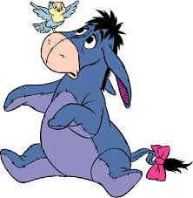
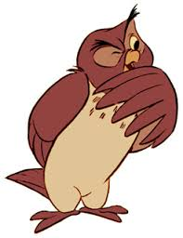
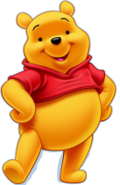
Kanga—Responsible
We look after property
Winnie the Pooh—Respectful
We are gentle, kind and helpful
Tigger—Resilient
We work hard
LEARNING BEHAVIOURS

Eeyore—Reasoning
We listen to others and
make the right choices
Owl—Resourceful
We try our best

I am a good friend!

I am good at solving problems!

I keep on
trying!

I am good at thinking!

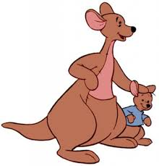
I am a reliable person!

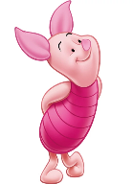
Piglet—Ready
We are ready to follow the Golden Rules

I am ready to learn !

Summary of the National Curriculum for KS1
For more information - https://www.gov.uk/national-curriculum/overview

Mathematics in Year 1
We continue to build on the learning that takes place in the Reception year. Here are some of the main things your child will be taught during their time in Year 1.
Number and Place Value
Place value is central to mathematics. Recognising that the digit ‘5’ in the number 54 has a different value from the number 5 or the ‘5’ in 504, is an important step in mathematical understanding.
• Count, both forwards and backwards, from any number, including past 100
• Read and write numbers up to 100 as digits
• Count in 2s, 5s and 10s
• Find ‘one more’ or ‘one less’ than a number
• Use mathematical language such as ‘more’, ‘less’, ‘most’, ‘least’ and ‘equal’
Calculations
• Use the +, -– and = symbols to write and understand simple number calculations
• Add and subtract one- and two-digit numbers, up to 20
• Solve missing number problems, such as 10 – ? = 6
• Begin to use simple multiplication by organising and counting objects
Fractions
• Understand 1/4 and 1/2 to explain parts of an object or number of objects
Measurements
• Use practical apparatus to explore different lengths, weights and volumes
• Use language such as ‘heavier’, ‘shorter’ and ‘empty’ to compare things they have measured
• Recognise the different coins and notes of British currency
• Use language of time, such as ‘yesterday’, ‘before’, days of the week and months of the year
• Tell the time to the hour and half-hour, including drawing clock faces
Shape
• Recognise and name some common 2-d shapes, such as squares, rectangles and triangles • Recognise and name some common 3-d shapes, such as cubes, cuboids and spheres •Describe movements, including quarter turns

Mathematics in Year 2
During Key Stage 1, there is a big focus on developing basic number skills. That means securing a good understanding of place value, and recognising number bonds to 20. Practising these skills frequently will help children’s mathematical thinking throughout school.
Number bonds are essential to the understanding of maths. Children in Year 2 learn their number bonds to 20, that is being able to quickly recall the total of any two numbers up to 20, e.g. 5 + 9 = 14, rather than having to count on to find the answer.
At the end of Year 2, all children will sit the National Curriculum Tests for Key Stage 1. This will include an arithmetic test of 15 questions, and a second paper of broader mathematics which will last around 35 minutes.
Number and Place Value
• Recognise place value in two-digit numbers, e.g. knowing that the 1 in 17 represents 10
• Read and write numbers up to 100 as words
• Count in 2s, 3s and 5s
• Compare and order numbers up to 100
• Use the < and > symbols to represent the relative size of numbers
Calculations
• Recall number bonds up to 20 fluently
• Add and subtract numbers mentally and using objects, including two-digit numbers
• Show that adding two numbers can be done in any order, but subtracting cannot
• Recognise that addition and subtraction are inverse operations
• Learn the multiplication and division facts for the 2x, 5x and 10x tables
• Show that multiplying two numbers can be done in any order, but dividing cannot
• Solve problems using the x and ÷ symbols
Fractions
• Find 1/4, 2/4 and 3/4 of an object or set of objects
• Find the answer to simple fraction problems, such as finding 1/2 of 6
Measurements
• Use standard units to measure length (centimetres and metres), mass (grams and kilograms), temperature (degrees Celsius) and capacity (millilitres and litres)
• Use the £ and p symbols for money amounts
• Combine numbers of coins to make a given value, for example to make 62 pence
• Tell the time to the nearest five minutes on an analogue clock
• Know the number of minutes in an hour and hours in a day
Shape
• Identify the number of sides and a line of symmetry on 2-d shapes
• Identify the number of faces, edges and vertices on 3-d shapes
• Use mathematical language to describe position and direction, including rotations and turns
Graphs and Data
• Construct and understand simple graphs such as bar charts and pictograms

English in Year 1
Our focus is to develop confident readers, mainly using the phonics approach. Phonics is the relationship between printed letters and the sounds they make. Children will first learn the most common letter sounds, and then look at more difficult patterns such as recognising that ‘ow’ sounds different in ‘cow’ than in ‘low’, or that both ‘ai’ and ‘ay’ make the same sound in different words. Our phonics teaching programme uses Letters and Sounds, Jolly Phonics and our own scheme which links with teaching cursive handwriting. Please come to our Parent Workshops in the Autumn and Spring terms.
Speaking and Listening
The national curriculum for English reflects the importance of spoken language in pupils’ development across the whole curriculum – cognitively, socially and linguistically. Spoken language underpins the development of reading and writing. The quality and variety of language that pupils hear and speak are vital for developing their vocabulary and grammar and their understanding for reading and writing.
The focus in Year 1 is to:
• Listen and respond to adults and other children
• Ask questions to extend their understanding
• Learn new vocabulary related to topics or daily life
Reading Skills
• Learn the 40+ main speech sounds in English and the letters that represent them
• Blend sounds together to form words
• Read aloud when reading books that contain familiar letter sound patterns
• Listen to, and talk about a range of stories, poems and non-fiction texts
• Learn about popular fairy tales and folk stories, and retell the stories
• Join in with repeated phrases in familiar books
• Make predictions about what might happen next in a book
• Explain clearly what has happened in a book they’ve read or listened to
Writing Skills
• Hold a pen or pencil in the correct and comfortable way
• Name the letters of the alphabet in order
• Write lower-case letters starting and ending in the right place
• Write capital letters and the digits 0 to 9
•Spell simple words containing the main sounds they’ve learned in reading
• Spell the days of the week
• Learn to write words with common endings, such as –ed, –ing, –er and –est
• Plan out sentences aloud before writing them
• Write simple sentences, and those using joining words such as ‘and’
• Begin to use full stops and capital letters for sentences
• Combine some sentences to make short descriptions or stories
English in Year 2
As children move through Key Stage 1, the new curriculum intends that almost all children will secure the basic skills of decoding so that they can become fluent readers. As their reading confidence grows they can begin to write their own ideas down.
Decoding is the ability to read words aloud by identifying the letter patterns and matching them to sounds. Once children are able to ‘decode’ the text, they can then start to make sense of the words and sentences in context. Watch out for hard-to-decode words such as ‘one’ and ‘the’. These just have to be learned by heart.
At the end of Year 2, all children will sit the National Curriculum Tests for Key Stage 1. These will include two short reading tests, a grammar and punctuation test, and a spelling test.

Speaking and Listening
The focus in Year 2 includes:
• Articulate and justify answers and opinions
• Give well-structured explanations and narratives, for example in show-and-tell activities
Reading Skills
• Read words aloud confidently, without obvious blending or rehearsal
• Learn letter patterns so that decoding becomes fluent and secure by the end of Year 2
• Blend letter sounds, including alternative patterns, e.g. recognising ‘ue’ as the ‘oo’ sound
• Read aloud words which contain more than one syllable
• Recognise common suffixes, such as –ing and –less
• Read words which don’t follow phonetic patterns, such as ‘one’ and ‘who’
• Become familiar with a wide range of fairy stories and traditional tales
• Discuss favourite words and the meaning of new words
• Check that what has been read makes sense, and self-correct reading where necessary
• Make predictions about what might happen next in a story
Children will be expected to read aloud books which are appropriate for their reading ability. During Year 2 their increasing knowledge of decoding should allow them to read a wide range of children’s books.
Writing Skills
• Write about real events and personal experiences
• Spell longer words by breaking them into their sound parts
Spell 100 common words, including 100 Common Words which are not decodable
• Learn to spell some common homophones, recognising the difference between them
(Homophones are words which sound the same, such as ‘blue’ and ‘blew’, or ‘one’ and ‘won’)

• Use the possessive apostrophe in simple phrases, such as ‘the boy’s football’.
• Plan out writing in advance, including by writing down key words
• Re-read writing to check that it makes sense and to make corrections, including punctuation
• Use question marks, exclamation marks, apostrophes and commas in lists
• Use the present and past tenses correctly in writing
• Begin to write longer sentences by using conjunctions, such as ‘and’,’ but’, ‘if’ or ‘because’
• Form letters of the appropriate size, using capital letters where appropriate
• Use appropriate spaces between words when writing
• Begin to use joins between letters where needed

Science in Year 1
In the first years of schooling, much of the science curriculum is based around real-life experiences for children. This includes everyday plants and animals, as well as finding out about different materials and the four seasons. There are likely to be lots of opportunities for exploring scientific ideas both in the classroom and the local surroundings.
Scientific Investigation
Children are encouraged to carry out their own observations and experiments to further their scientific understanding. In Year 1 this may include learning to:
• Ask scientific questions
• Carry out simple tests, and make observations
• Collect information to answer questions
• Group together objects according to their properties or behaviours

Plants and Animals
• Name a selection of common plants, including deciduous and evergreen trees
• Name the main parts of plants and trees, such as roots, stems, trunks and leaves
(Deciduous trees are those which lose their leaves in autumn, whereas evergreen trees – as the name implies – are those which retain their green colour all year round).

• Name a variety of common animals, including mammals, fish, birds, reptiles and amphibians
• Name some common animals which are carnivores, herbivores and omnivores
(Herbivores: animals which feed only on plants, e.g. rabbits
Carnivores: animals which feed on other animals, e.g. eagles
Omnivores: animals which eat both plants and animals, e.g. humans )

• Name the main parts of the human body, including those related to the five senses

Everyday Materials
• Recognise that objects are made of materials
• Name some everyday materials such as wood, metal, glass and plastic
• Describe some of the properties of materials, e.g. that wood is hard
• Group together items based on the materials they’re made from, or their properties, for example by grouping heavy objects or shiny objects

Seasonal Change
• Observe changes across the four seasons
• Observe and describe how the day and weather changes with the seasons.

Science in Year 2
Scientific Investigation
Children are encouraged to carry out their own observations and experiments to further their scientific understanding. In Year 2 this may include learning to:
• Use scientific apparatus to make observations, such as magnifying glasses
• Collect information about what they have seen
• Make links between observations and their scientific understanding
Living Things and their Habitats
• Compare the difference between things which are alive, which are dead, and which have never been alive
• Understand that different animals are suited to different habitats
• Identify some plants and animals in different habitats
• Describe how animals feed on other plants or animals
Habitats are simply the different types of places living things are found. This can range from the vast, such as oceans and rainforests, through to local features such as rock pools, or to the small, such as under a single log.
Plants
• Describe how seeds or bulbs grow into plants
• Understand that plants need water, light and a suitable temperature to grow
Animals including Humans
• Notice that all animals have offspring which grow into adults, including humans
• Know about the basic survival needs of animals, such as food, water and air
• Describe the importance of exercise, healthy diet and hygiene to humans
Everyday Materials
• Identify and compare the uses of different materials including wood, metal, plastic, glass, brick, rock, paper and cardboard
• Find out how some solid objects can be changed by squashing, bending or stretching

The Foundation Subjects
At primary school, English, Maths and Science are the core subjects which make up the bulk of the timetable. That said, the other foundation subjects play a key part in providing a broad and balanced curriculum. All eight of these subjects are a compulsory part of the National Curriculum. In addition, all schools are required to include some Religious Education in their broader curriculum, although the content of this is agreed locally.
Here is a very brief outline of what will be covered in the foundation subjects in an Infant School:
Art
Children will explore a range of different techniques such as drawing, painting and sculpture, and will use a variety of materials, from pencil and paint to charcoal and clay, to create their own art pieces.
Computing
There are three main strands of the new Computing curriculum: information technology, digital literacy and computer science. Information technology is about the use of computers for functional purposes, such as collecting and presenting information, or using search technology. Digital literacy is about the safe and responsible use of technology, including recognising its advantages for collaboration or communication. Finally, computer science will introduce children of all ages to understanding how computers and networks work. It will also give all children the opportunity to learn basic computer programming, from simple floor robots in Years 1 and 2, right up to creating on-screen computer games and programmes by Year 6. All schools will also include regular teaching of e-safety to ensure that children feel confident when using computers and the Internet, and know what to do if they come across something either inappropriate or uncomfortable. Many schools will also invite parents to work with them on this aspect of the curriculum.
Design and Technology
Through DT, children find out about a healthy diet and preparing simple meals. It also includes the more traditional design elements in which children will design, make and evaluate products while learning to use a range of tools and techniques for construction. There may also be some cross-over with Science here as children incorporate levers, pulleys or electrical circuits into their designs for finished products.

Geography
In Key Stage 1, children will learn the names and locations of the continents and oceans as well as the names of the four home nations and their respective capital cities. They will use the four main compass directions and simple maps and photographs to explore the local area.
History
In Key Stage 1, the focus of history is very much on locally significant events or events within their own memories, as well as key events of great significance such as Bonfire Night. In addition, children will find out about important historical people and events, such as Florence Nightingale or The Great Fire of London.
Music
Over the course of primary school, children will listen to and perform a range of music. In the first years of schooling this will often include singing songs and rhymes, and playing untuned instruments such as tambourines or rainmaker sticks and sound shapes. Singing and performing is a major part of our music curriculum. Children in Year 2, also have the opportunity to play recorder, hand bells and to compose.
Physical Education
Physical Education lessons will continue to include a range of individual disciplines such as dance and athletics, with team sports and games. Through these sports, children should learn the skills of both cooperation and competition.

EXPECTATIONS OF LEARNING AT THE END OF YEAR 2
WTS – working towards the expected standard
EXS – working at the expected standard
GDS – working at greater depth within the expected standard
WRITING – (spelling, composition, punctuation, grammar) Your child can:- | WTS | EXS | GDS
use real experiences or fictional ideas to write | sequenced sentences in a short narrative | simple, coherent narratives | effectively & coherently for different purposes
use punctuation taught at key stage 1 | capital letters and full stops sometimes | capital letters and full stops correctly | capital letters,  and . ? ! , ’  mostly correctly
use present and past tense | sometimes | mostly correctly | correctly
join clauses using | and | or/ and/ but  when/ if/ that/because | or/ and/ but /  when/ if/ that/because  effectively
spell words correctly by segmenting | some | many | most
spell common exception words correctly | some | many | most
adding suffixes correctly | -ing -ed | –ing, –ed,  –er, –est, –y | –ment, –ness,  –ful, –less, –ly
write capital and lower case letters at correct size and orientation | sometimes | consistently | cursively
READING Your child can:- | WTS | EXS | GDS
read age-appropriate words accurately and sufficiently fluently to allow them to focus on their understanding rather than on decoding individual words | many | most | all
read common exception words in the Year 2 curriculum | many | most | all
sound out most unfamiliar words accurately and fluently, without undue hesitation | many | most | all
answer questions about familiar texts | with support | fluently | linking to other texts
make inferences about what they have read | simply | some | accurately

MATHS  Your child can:- | WTS | EXS | GDS
partition any two-digit number into tens and ones | using resources to support them | using different combinations of tens and ones | explaining their thinking fluently
add and subtract, explaining their method verbally, in pictures or using apparatus | two-digit numbers + ones, and two-digit numbers + tens | any 2 two-digit numbers using an efficient strategy | solving word problems that involve more than one step
recall number facts and reason about associated facts | at least four of the six number bonds for 10 | all number bonds to and within 10 using these to calculate bonds to and within 20 | to solve more complex problems, explaining their thinking
recall multiplication and division facts for 2, 5 and 10, using them to solve simple problems, | count in twos, fives and tens from 0 | demonstrating an understanding of commutativity as necessary | making deductions outside known facts
identify fractions of a number or shape | recall doubles and halves to 20 | 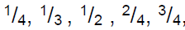  knowing that all parts of the whole must be equal | find and compare fractions of amounts
use British coins to make an amount | knowing the value of different coins | using different coins to make the same amount | paying for more than one item calculating the change
read time on an analogue clock | to nearest half hour | to nearest quarter hour | to nearest five minutes
read scales in divisions of ones, twos, fives and tens | in a practical situation | on a number line | estimating points in between
name and describe properties of 2-D and  3-D shapes | some | all | describing similarities and differences

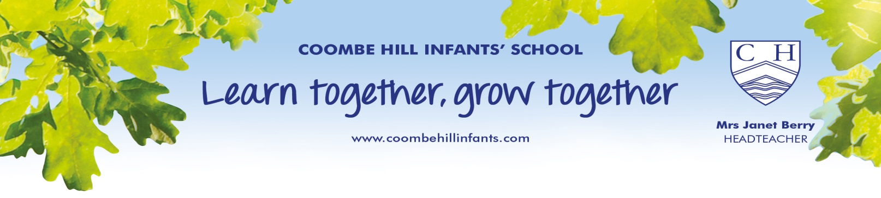

“Learning is very much a social and socialising activity for young children .... schools provide massive opportunities and unique advantages for developing their speaking and listening skills. Such development depends upon creating conditions for children to interact with others: to engage frequently in worthwhile talk and attentive listening, build a good stock of words, explore how language works, understand what is said to them and respond appropriately – well before reading begins. The best work with children draws frequently on the power of story, drama and music to fire their imagination and enrich their language. The importance for young children of learning co-operatively in language rich contexts cannot be overstated.”
Rose Report

